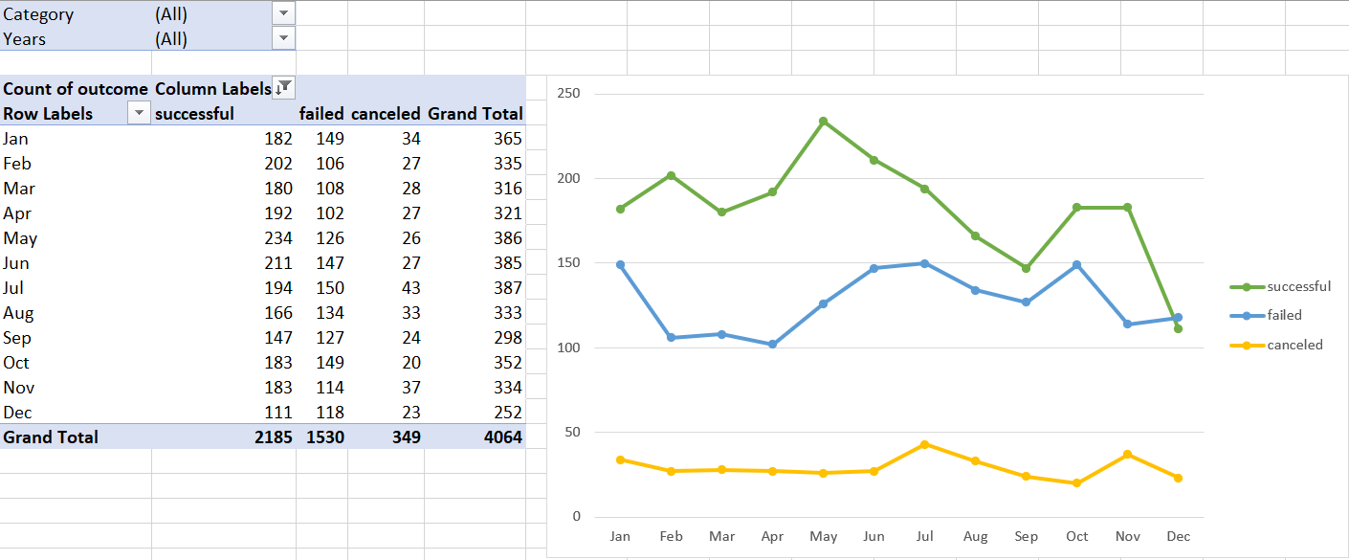

1. Given the provided data, what are three conclusions we can draw about Kickstarter campaigns?

* There are more successes than failed and canceled campaigns.
* Campaigns launched in May have the highest success rate.
* Campaigns launched in December have the lowest success rate.

1. What are some limitations of this dataset?

* The dataset only models 4000 past projects out of more than 300,000 projects launched, hence the test data may not be large enough and lacks accuracy.
* The scope of data ranges from year 2009 to 2017, hence uncovered trends may not be current.
* Unable to determine how these projects were shortlisted, hence the dataset may not be the best representative of all projects.

1. What are some other possible tables and/or graphs that we could create?

* What categories and sub-categories are backers mostly interested to donate in and if they have changed over time?
* Does duration of campaign affect campaign success rate?
* How popular are kickstarter campaigns in varying countries and if they have changed over time?